Instructions for Preparing

Base Budget Submissions

2014-2016 Biennial Budget

Department of Planning and Budget
May 2013

TABLE OF CONTENTS

Base Budget Overview 1
About the Base Budget Submission 1
What’s new or different this year? 1
Things to Consider 1
Budget Calendar 2
Personal Services 2
Vacant Positions 2
Vacancy Savings 3
Authorized Position Level 3
Benefit Rates 4
Nonpersonal Services 5
Required Nonpersonal Service Subobject Codes 5
Allowable Nonpersonal Convenience Codes 6
Sum Sufficient Appropriations 7
Components 7
Strategic Link 7
Performance Budgeting System Instructions 8
Base Budget Module Quick Guides 8
Overview Tab Overview 9
Overview Tab Instructions 10
Base Budget Tab Overview 11
Base Budget Tab Instructions 11
Position Planning Tab Overview 12
Position Planning Tab Instructions 12
Components Overview 16
Components Instructions 16
Strategic Link Overview 17
Strategic Link Instructions 17

Base Budget Overview

About the Base Budget Submission
This package of instructions is the first your agency will receive over the next several months related to the development of the 2014-2016 biennium budget that will be presented by the Governor for the 2014 Session of the General Assembly. This package provides guidance and instructions for the preparation of your agency’s base budget, which is due to DPB by June 21, 2013.
The base budget submission captures the line item dollar and position details which will become the starting point for 2014-2016 biennial appropriations. DPB has created base budget targets in the Performance Budgeting System against which you will spread line item details by fund detail and subobject. The base budget submission is technical in nature and must total to the targets created by DPB. These targets are equal to FY 2014 appropriations in Chapter 806, 2013 Virginia Acts of Assembly. (A detailed listing of base budget targets is available on the DPB Website.) You will use the base budget module in the Performance Budgeting System to create your base budget submission. See Appendix A for detailed instructions on this module.
As alluded to in the opening paragraph, additional instructions will be issued by DPB for changes to your base budget. These will include required changes in the form of base adjustments and other changes in the form of technical decision packages and other budget decision package requests.
What’s new or different this year?
- Budget calendar. As you may have noticed, June is an earlier deadline for base budget submissions as compared to previous years. While the due dates for budget development this summer may occur earlier than they have in the past, the new budget development calendar is designed so that there is more time than previous years to get submissions completed. In addition, the new calendar minimizes the overlap in budget development activities as compared to years past. For more calendar information, see the “Budget Calendar” section on the next page.
- Linking to Strategic Plans. A new requirement in the Performance Budgeting System’s base budget module for agencies that participate in strategic planning is to allocate agency service area budgets to strategic plan performance measures or objectives. For more information, see the “Strategic Link” section of these instructions.
Things to Consider
As you prepare your base budget submission, you should “clean up” any unnecessary detail in the submission. For example, if you have several detail records for a specific service area and fund combination that sum to zero when added together, please consider removing this detail (excluding details for sum sufficient appropriations).
These instructions provide guidelines and requirements for personal services, nonpersonal services, and sum sufficient appropriations. Please familiarize yourself with these instructions and the Performance Budgeting System base budget module instructions included in Appendix A prior to beginning your submission.

Please contact your DPB budget analyst with any questions or concerns.

Budget Calendar

Below is a tentative calendar for the preparation of the initial 2014-2016 biennium budget that will be submitted by the Governor to the General Assembly on December 16, 2013:
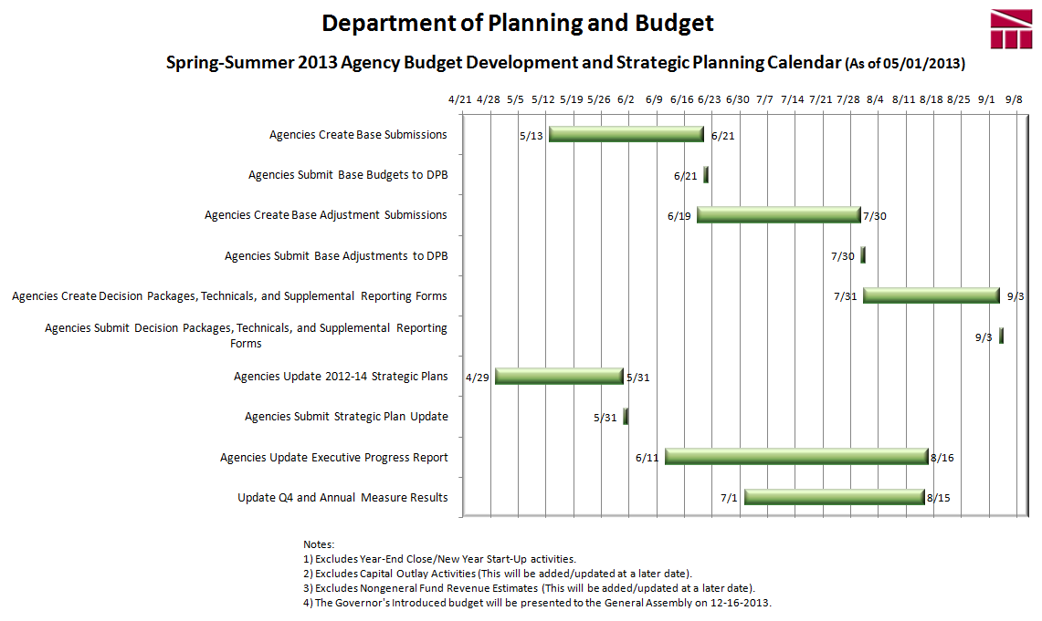
(Go to http://dpb.virginia.gov/forms/20130426-2/BudgetCalendarAgency.pdf to see a larger version of the latest Budget Calendar on the DPB Web Site)

Personal Services

Vacant Positions
For your 2014-2016 base submission, you should not fund 100 percent of your agency’s authorized position level unless you plan to keep filled positions at or near the authorized position level (that is, no vacancies) in FY 2015 and/or FY 2016. Instead, you should fund a position level that is more consistent with your current filled position level including a reasonable amount for anticipated turnover and vacancy. To identify the vacancy rate in your agency, you should indicate the number of authorized positions not being funded using subobject 1182 (Unfunded Vacant Positions). For those positions -that are part of your budgeted amount for turnover and vacancy-, you should use subobjects 1192 (faculty positions) or 1195 (classified positions). You should indicate the filled authorized position level that you are funding using the usual subject codes that are valid for position numbers (e.g., 1123 and 1124).
Your total authorized position level in your base submission should still match the position totals as shown in FY 2014 of Chapter 806, but the subobject detail for these authorized positions will break them out by those you are funding in the submission versus those you are not funding. For example, assume an agency that has 50 authorized positions in FY 2014 of Chapter 806 and plans to fund 40 positions with a reasonable vacancy rate of five positions. This agency would then budget 40 positions on typical salary subobjects (1123, 1124, etc.), five positions on 1195 (classified positions turnover and vacancy) or 1192 (faculty positions), and the remaining five on 1182 (Unfunded Vacant Positions).
Vacancy Savings
If your base submission does include dollar amounts for turnover and vacancy, you may use the following designated convenience codes to identify the savings associated with such vacancy and turnover:
1192 | Turnover/Vacancy Faculty Salaries
1193 | Turnover/Vacancy Fringe Benefits
1194 | Turnover/Vacancy Medical/Hospital Insurance
1195 | Turnover/Vacancy Classified Salaries

Please do not use any other convenience codes for personal services.
Authorized Position Level
Position level detail in the Performance Budgeting System base budget module is not automatically pre-populated when the user chooses to auto-populate dollar amounts. Because of this, DPB has made available on its Web Site, a listing of the position level detailed appropriation included in the 2013 Appropriation Act for FY 2014. You may choose to use data from this source to import into the Performance Budgeting System (see the “Position Planning Tab” section of the Performance Budgeting System instructions included in Appendix A for more details).

Remember that positions can be carried out to two decimal places. Also, positions can be assigned only to personal services subobject codes.

Benefit Rates
Due to the fact that the totals of the base budget submission must match the agency totals in Chapter 806, your funding will not include fringe benefit changes that have occurred during the 2012-14 biennium. These changes are budgeted separately in Central Appropriations. These amounts will be added to your agency 2014-16 budget as a part of the base adjustments submission later during budget development. Consequently, the rates you will be using to calculate personal services costs for the 2014-2016 base submission will not be the benefit rates you will use in budget execution for FY 2014. The “Base Budget Rates/Factors” column in the table below shows the benefit rates you will use in your base budget submission. The decision package and base adjustment rates are included for your information.
Sub Object | Benefit |  | Base Budget  Rates/ Factors ¹ | Base Adjustment/Decision Package  Rates/Factors¹
1111 | VRS Retirement Contributions
 | State Employees |  | 6.58% | 8.76%
 | Virginia Law Officers Retirement (VaLORS) |  | 13.09% | 14.80%
 | State Police (SPORS) |  | 21.16% | 24.74%
 | Judges (JRS) |  | 42.58% | 45.44%
1112 | Social Security ² |  | 6.20% capped at $113,700
1112 | Medicare |  | 1.45% | 1.45%
1114 | Group Life |  | 1.02% | 1.19%
1115 | Annual Employer Health Insurance Premiums
 | COVA Care | Single | $4,596 | $6,024
 |  | Employee + One | $8,232 | $10,812
 |  | Family | $12,024 | $15,852
 | COVA High Deductible | Single | $3,924 | $5,172
 |  | Employee + One | $7,272 | $9,600
 |  | Family | $10,632 | $14,028
 | HealthAware | Single | $0 | $6,024
 |  | Employee + One | $0 | $10,812
 |  | Family | $0 | $15,852
 | Kaiser Permanente | Single | $4,872 | $5,604
 |  | Employee + One | $8,736 | $9,972
 |  | Family | $12,756 | $14,580
1116 | Retiree Health Insurance Credit Premium |  | 0.99% | 1.00%
1117 | VSDP & Long-Term Disability Insurance |  | 0.66% | 0.47%
1118 | Teachers Insurance and Annuity³ Plan 1 |  | 10.40% | 10.40%
1118 | Teachers Insurance and Annuity³ Plan 2 |  | 8.50% | 8.50%
1119 | Defined Contribution Plan⁴ |  | 10.40% | 10.40%
1138 | Deferred Compensation Match Payments |  | One-half of employee’s contribution per pay period, up to a max of $20 per pay period or $480 annually
¹ Percentages refer to percent of salaries. Health insurance premiums are the annual employer dollar cost for an individual.
² The $113,700 Social Security cap applies to calendar year 2013. Future year caps are unknown at this time.
³ For institutions of higher education: This includes alternative retirement options, such as TIAA-CREF, for those employees as defined in § 51.1-126 of the Code of Virginia. Plan 1 employees are those employees hired before July 1, 2010. Plan 2 employees were hired after June 30, 2010.
⁴ Used for employees eligible for a defined contribution plan established pursuant to § 51.1-126.5 of the Code of Virginia.

Nonpersonal Services

For all nonpersonal services, you must array your planned expenses by major object of expenditure unless a more detailed subobject submission is required. In order to obtain more detailed and accurate information about selected expenses, you must use the subobject codes listed below, if applicable to your anticipated expenses. The purpose of collecting budget information at the more detailed subobject level for these selected subobject codes is to better identify these areas of cost and to more completely understand the impact of agency based rate changes. In other cases, the subobject detail represents an area targeted for cost control and/or management, or an area where better tracking of costs are needed.
Any remaining dollar amount for nonpersonal services beyond those required in the list below may be grouped in the “xx95” convenience codes, which are listed on the following page. No other convenience subobject codes may be used.
Required Nonpersonal Service Subobject Codes

1205 | Seat Management Services
1214 | Postal Services
1215 | Printing Services
1216 | Telecommunications Services (provided by VITA)
1217 | Telecommunications Services (provided by non-state vendor)
1218 | Telecommunications Services (provided by another state agency)
1241 | Auditing Services
1242 | Fiscal Services
1243 | Attorney Services
1244 | Management Services
1245 | Personnel Management Services
1246 | Public Informational and Public Relations Services
1247 | Legal Services
1248 | Media Services
1271 | Information Management Design and Development Services (provided by VITA)
1272 | VITA Pass Thru Charges
1273 | Information Management Design and Development Services (provided by another State agency (not VITA) or vendor)
1274 | Computer Hardware Maintenance Services
1275 | Computer Software Maintenance Services
1276 | Computer Operating Services (provided by VITA)
1277 | Computer Operating Services (provided by another State agency (not VITA) or vendor)
1278 | VITA Information Technology Infrastructure Services (Provided by VITA)
1279 | Computer Software Development Services
1292 | VITA Services Provided to Out of Scope Agencies
1321 | Coal
1322 | Gas
1323 | Gasoline
1324 | Oil
1325 | Steam
1326 | Wood Fuels
1431 | Categorical Aid to Local Governments and Constitutional Officers (Not Technology)
1432 | Payments in Lieu of Taxes
1433 | General Revenue Sharing
1434 | Disaster Aid to Local Governments
1435 | Special Payments to Localities
1436 | Categorical Aid to Local Governments and Constitutional Officers for Technology
1441 | Payments to Substate Entities
1442 | Payments to Individuals
1451 | Grants to Intergovernmental Organizations
1452 | Grants Nongovernmental Organizations
1453 | Out-of-State Political Entities
1455 | Disaster Cost Reimbursements to Other State Agencies
1456 | Disaster Aid to Nongovernmental Organizations
1511 | Aircraft Insurance
1512 | Automobile Liability
1513 | Flood Insurance
1514 | Inland Marine Insurance
1515 | Marine Insurance
1516 | Property Insurance
1517 | Boiler and Machinery Insurance
1521 | Computer Capital Leases
1522 | Central Processor Capital Leases
1523 | Computer Software Capital Leases
1524 | Equipment Capital Leases
1525 | Building Capital Leases
1526 | Land Capital Leases
1527 | Land and Building Capital Leases
1531 | Computer Rentals (not mainframe)
1533 | Computer Software Rentals
1534 | Equipment Rentals
1535 | Building Rentals
1536 | Land Rentals
1537 | Land and Building Rentals
1538 | Building Rentals – State Owned Facilities
1539 | Building Rentals – Non-State Owned Facilities (Payment administered by DGS)
1542 | Electrical Service Charges
1543 | Refuse Service Charges
1544 | Water and Sewer Service Charges
1547 | Private Vendor Service Charges
1551 | General Liability Insurance
1552 | Money and Securities Insurance
1553 | Medical Malpractice
1554 | Surety Bonds
1555 | Workers' Compensation
1561 | Computer Peripheral Installment Purchases
1562 | Computer Processor Installment Purchases
1563 | Computer Software Installment Purchases
2211 | Desktop Client Computers (microcomputers)
2212 | Mobile Client Computers (microcomputers)
2214 | Mainframe Computers and Components
2215 | Network Servers
2216 | Network Components
2217 | Other Computer Equipment
2218 | Computer Software Purchases
2219 | Development Tools Purchases
3111 | Bond Issuance Expenses
3112 | Bond Issuance Fees
3113 | General Obligation Bond Financing
3114 | General Obligation Bond Interest Retirement
3115 | Revenue Bond Financing
3116 | Revenue Bond Interest Retirement
3117 | Revenue Bond Principal Retirement
3121 | Anticipation Loan Interest Retirement – Not drawdown or mortgage loans
3131 | Anticipation Loan Interest Retirement – Drawdown and Mortgage Loans
3132 | Mortgage Loan Interest Retirement
3196 | Indirect Cost Recoveries from Auxiliary Programs for Obligations
3198 | Inter-Agency Recoveries for Obligations
3199 | Intra-Agency Recoveries for Obligations

Allowable Nonpersonal Convenience Codes

1295 | Undistributed Contractual Services
1395 | Undistributed Supplies and Materials
1495 | Undistributed Transfer Payments
1595 | Undistributed Continuous Charges

2195 | Undistributed Property and Improvements
2295 | Undistributed Equipment
2395 | Undistributed Plant and Equipment
3195 | Undistributed Obligations

Sum Sufficient Appropriations

Internal service fund requests will involve the same level of base budget entry as other requests with the exception and use of a recovery subobject code. More specifically your entries on sum sufficient and/or internal service fund requests, should array budget requests by program, service area, subobject code, and fund detail for all expenditures and then use subobject code 4101 (Sum Sufficient Recovery) to offset the total dollar amount being requested at the service area level.

It is important to note that you should enter a request for positions supported by the sum sufficient appropriation in the same manner as any other request for positions.

Components

Components are a discrete portion of an agency’s budget that further breaks down its activities or services. As with the base submission created two years ago, you must allocate your agency’s base budget across components. For detailed instructions on completing this requirement, see the Performance Budgeting System instructions included in Appendix A. A detailed listing of the components records used by your agency that equal to the budgeted amounts included in FY 2014 in Chapter 806 is included on the DPB Web Site. You may choose to use data from this source to import into the Performance Budgeting System.

Strategic Link

For Executive branch agencies that participate in strategic planning in the Performance Budgeting System, there is a new requirement in the Base Budget submission to allocate service area budgets to elements of the strategic plans. Specifically, for each service area, you must allocate the percentage of GF and NGF that support given objectives or measures in your agency’s strategic plan. You may allocate to either the objective or the measure level. For additional information and detailed instructions on completing this requirement, see the Performance Budgeting System instructions included in Appendix A.

APPENDIX A

Performance Budgeting System Instructions

Base Budget Module

The base budget module captures the line item dollar and position details which become the starting point for agency biennial appropriations. The Department of Planning and Budget creates base budget targets that are equivalent to the second year appropriation of the most recent Appropriation Act. Agencies use the base budget module to spread these targeted amounts to fund and subobject details.

To access the base budget module, select “Base Budget” under the “Operating Budget” menu. This will create a new base budget work item. At any time you may submit or save the work item as indicated in the instructions below. The work item will then be available in the work tray for you and others with the same permissions in the Performance Budgeting System.

If you have any questions of a policy nature, please contact your DPB budget analyst. If you experience technical issues with the Performance Budgeting System, please contact the VCCC help desk at vccc@vita.virginia.gov (make sure to indicate in the subject line that you are experiencing a Performance Budgeting System issue so the ticket can be routed to the Performance Budgeting System help desk).
Base Budget Module Quick Guides

AGENCY ANALYST QUICK GUIDE
- Mouse over the Operating Budget Functional Area menu item and select Base Budget from the resulting dropdown menu. Once Base Budget is selected, the Overview tab will appear.
- Complete the Overview tab as described in the Overview tab instructions.
- Complete the Position Planning tab as described in the Position Planning tab instructions.
- Complete the Base Budget tab as described in the Base Budget tab instructions.
- Complete the Allocation Across Components tab as described in the Allocation Across Component instructions.
- Complete the Strategic Link tab as described in the Strategic Link instructions.
- Review the Base Budget before submitting to the Agency Reviewer. Make sure to load the correct scenario before submitting the base budget to the Agency Reviewer.
- Click Submit and select the appropriate action from the available options.
- Continue Working - Saves the base budget and returns it to the Available Work Items tab on the Work Tray for users with similar credentials to claim.
- Submit for Agency Review - Submits the base budget to the next step in the workflow.
- Void Document - Voids the base budget.

AGENCY REVIEWER QUICK GUIDE
- Click on Available Work Items from the Work Tray.
- Select the Document Type filter and select Base Budget to filter on the base budget work items.
- Click the Claim button next to the base budget that is ready for review. Once the base budget is claimed, the Overview tab will appear.
- Review the Overview tab for completeness and accuracy. Refer to the DPB transmittal for policy guidance. Make sure the correct scenario is loaded before reviewing and submitting the base budget to DPB.
- Click on the Base Budget tab and review for completeness and accuracy. Refer to the DPB transmittal for policy guidance.
- Click on the Position Planning tab and review for completeness and accuracy. Refer to the DPB transmittal for policy guidance.
- Click on the Allocation Across Components tab and review for completeness and accuracy.
- Click on the Strategic Link tab and review for completeness and accuracy.
- Click Submit and select the appropriate action from the available options.
- Continue Review - Saves the base budget and returns it to the Available Work Items tab on the Work Tray for users with similar credentials to claim.
- Submit for DPB Review - Submits the base budget to DPB.
- Return for Further Data Entry - Returns the base budget to the data entry workflow step.
- Void Document - Voids the base budget.

Overview Tab

Overview Tab Overview
The purpose of the Overview tab is to capture identifying information for a base budget and select the level at which the budget details will be entered. Additionally, the ability to save multiple scenarios of the base budget and pre-populate the base budget using previously entered values is provided.

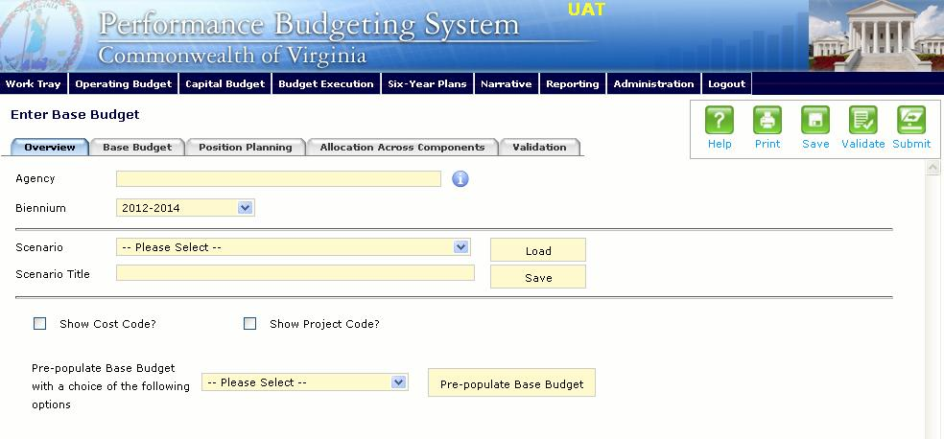

Overview Tab Instructions
- Click on the Overview tab.
- Select the Agency for which the base budget is being prepared.
- Select the Biennium to which the base budget will be applied.
- To create a new base budget scenario, enter the Scenario Title for the agency base budget and then click Save. To work with an existing scenario, select the Scenario, and then click Load. Once you are done working with a scenario, click Save again before submitting the base budget.
- Check Show Cost Code? and/or Show Project Code? If the base budget will be entered at the cost code level, project code level, or both.
- Check Strategic Planning allocation not required? If your agency does not participate in strategic planning in the Performance Budgeting System. Participating agencies should leave this unchecked and will need to complete the information on the Strategic Link tab.
- To pre-populate the Total Services Grid on the Base Budget tab (1st and 2nd years of the biennium) with existing data, make a selection from the Pre-populate Base Budget with a choice of options in the Pre-Populate Base Budget dropdown and then click the Pre-populate Base Budget button. The choices are as follows:
  - a) ASP Base Budget Baseline (this option is for agencies that use the Agency Spend Plan module and choose to create their base budgets in that module);
  - b) Current Appropriated Amount (this option populates the Total Services Grid with the year two amounts from the most recently adopted Appropriation Act - these amounts are used to create the base budget targets found at the top of the Base Budget tab and as a result, is the most common selection);
  - c) Current Year Operating Plan (populates amounts equivalent to the amounts from option b listed above plus any execution transaction for year 2 - note: depending on the time of year base budgets are commenced, there may be little or no execution transaction activity);
  - d) Prior Year Actuals (this option uses CARS expenditure data from the latest completed fiscal year); and
  - e) Prior Year Operating Plan (this option uses appropriation from the prior year / year one of the biennium plus any execution transactions approved for that year.)

Base Budget Tab

Base Budget Tab Overview
The purpose of the Budget Detail tab is to capture the budget details, line by line, for the base budget. A user will be required to enter the program, fund, subobject, and FY 20XX and FY 20XX dollars for each budget line associated with the base budget. If a user specified that they would be budgeting at the cost code and/or project code levels, then they will be allowed to enter this level of detail when entering the budget details. Additionally, the Position Planning tab must be used to budget for any positions associated with the base budget.

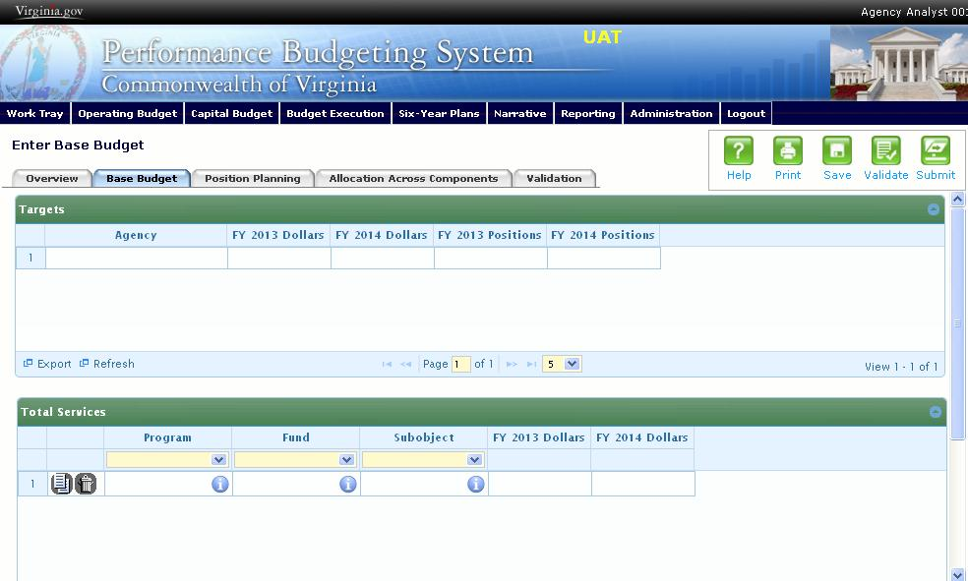
Base Budget Tab Instructions
- Click on the Budget Detail tab.
- Take note of the targets in the Targets grid as they will need to be met as described by DPB. Targets are established by DPB and can be for the program, fund or subobject dimensions.
- Confirm the personal services data that populated the Total Services grid from the Position Planning tab is correct. If the data is incorrect, return to the Position Planning tab to make corrections and then repopulate the data as described in the Position Planning tab instructions.
- In the Total Services grid, enter the Program (Program, Service Area or Component), Fund, and Subobject for each Non-personal Services budget line. Additionally, if applicable for the budget line, enter the Cost Code and/or Project Code.
- Add rows to the Total Services grid, by clicking the Add button in the lower left corner of the grid as needed in order to specify multiple Non-personal Services line items.

Position Planning Tab

Position Planning Tab Overview
The purpose of the Position Planning tab is to record the authorized positions associated with an agency's base budget. Additionally, users can optionally leverage the Commonwealth of Virginia’s existing HR data to budget for positions. Once the positions are entered, the personal services budget can be automatically calculated and the resulting budget data can be used to populate the personal services subobjects in the Total Services grid. For the base budget, users can opt out of using the position planning functionality and are only required to enter the total number of positions for each year of the biennium.

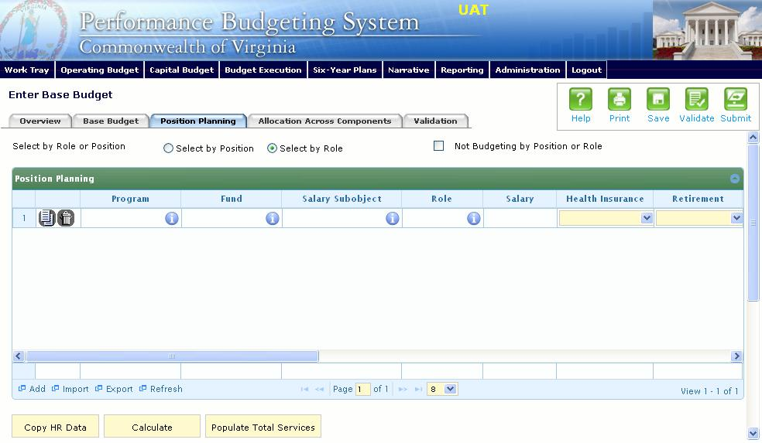
Position Planning Tab Instructions

Not Budgeting by Position or Role
Use this method if you do not need to calculate the cost of positions in the Performance Budgeting System and only want to record the authorized position level associated with the base budget.
- Click on the Position Planning tab.
- Check the Not Budgeting by Position or Role checkbox.
- In the Position Planning grid, enter the total number of positions for the Agency for both the first year and second years of the biennium in the FY 20XX Positions cells. This is required to be arrayed at the level at which the base budget Targets are set (i.e. Program, Service Area, Fund).
- To specify that positions are vacant for a budget line, check the Vacancy checkbox.
- Add rows to the Position Planning grid, by clicking the Add button in the lower left corner of the grid as needed.
- Authorized positions can also be uploaded from an .xls file.

Position Planning by Role
Use this method if you would like to use the capabilities of the Performance Budgeting System to assist in the calculation of the dollar costs of your agency's authorized position level.
- Click on the Position Planning tab.
- Select the Role radio button.
- (Optional) Click the Import from HR button to import HR data for the selected agency into the Imported HR Data grid.
- (Optional) Review the imported HR data in the Imported HR Data grid, and uncheck the Include? checkbox if you would like to omit a line of data during the copy of data into the Position Planning grid.
- (Optional) Click the Copy HR Data button to copy the data from the Imported HR Data grid to the Position Planning grid.
- In the Position Planning grid, enter or edit the Program, Fund, and Subobject for a role. Additionally, if applicable for the role, enter the Cost Code and/or Project Code.
- Select or edit the Role.
Enter the proper role title for the position you are requesting. Please contact the Department of Human Resource Management (DHRM), the DHRM website, or your agency human resource department for this proper role title.
- Enter or edit the Salary for the selected role.
Enter the base salary for the position being requested. Do not include any benefit amounts. The requested amount must be within salary range and should be based on starting salaries for recent hires in this role.
- Select or edit the Health Insurance for the role.
Select a health premium. You can select the statewide average, or the actual employers premium for single, employee plus one, and family coverage.
- Select or edit the Retirement for the role.
Select the retirement type for the position: regular VRS, VaLORS, SPORS, judges' retirement, or defined contribution.
- Enter or edit the number of pay periods for the role for the first year of the biennium in the FY 20XX Pay Periods cell if the role is valid for the first year of the biennium.
- Enter or edit the number of positions allocated to the specified role for the first year of the biennium in the FY 20XX Positions cell if the role is valid for the first year of the biennium.
- Enter or edit the FY 20XX Pay Periods and FY 20XX Positions, where 20XX is the second year of the biennium. Data will only be entered for the second year of the biennium if the role is valid for the second year of the biennium.
- Add rows to the Position Planning grid, by clicking the Add button in the lower left corner of the grid as needed.
- Once all roles have been added to the Position Planning grid, click the Calculate button to calculate the budget for both years of the biennium for the specified roles. This calculation is based upon the data entered for each role.
- Confirm the calculation of the budget for both the first and second years of the biennium FY 20XX Budget. If the amounts are not correct, edit the values entered for a role and recalculate the budget for that role.
- Once the budget for both years of the biennium for each role is satisfactory, click the Populate Total Services button to calculate the personal services budget for the Budget Details tab based upon the data entered in the Position Planning grid.

Position Planning by Position
Use this method if you would like to use the capabilities of the Performance Budgeting System to assist in the calculation of the dollar costs of your agency's authorized position level.
- Click on the Position Planning tab.
- Select the Position radio button.
- (Optional) Click the Import from HR button to import HR data for the selected agency into the Imported HR Data grid.
- (Optional) Review the imported HR data in the Imported HR Data grid, and uncheck the Include? checkbox if you would like to omit a line of data during the copy of data into the Position Planning grid.
- (Optional) Click the Copy HR Data button to copy the data from the Imported HR Data grid to the Position Planning grid.
- In the Position Planning grid, enter or edit the Program, Fund, and Subobject for the role. Additionally, if applicable for the position, enter the Cost Code and/or Project Code.
- Enter or edit the Position Title.
Enter the proper position title for the position you are requesting. Please contact the Department of Human Resource Management (DHRM), the DHRM website, or your agency human resource department for this proper title.
- Enter or edit the Salary for the selected position.
Enter the base salary for the position being requested. Do not include any benefit amounts. The requested amount must be within salary range and should be based on starting salaries for recent hires in this position.
- Select or edit the Health Insurance for the position.
Select a health premium. You can select the statewide average, or the actual employers premium for single, employee plus one, and family coverage.
- Select or edit the Retirement for the position.
Select the retirement type for the position: regular VRS, VaLORS, SPORS, judges' retirement, or defined contribution.
- Enter the number of pay periods for the position for the first year of the biennium in the FY 20XX Pay Periods cell if the position is valid for the first year of the biennium.
- Enter or edit the number of positions allocated to the specified position for the first year of the biennium in the FY 20XX Positions cell if the position is valid for the first year of the biennium.
- Enter or edit the FY 20XX Pay Periods and FY 20XX Positions, where 20XX is the second year of the biennium. Data will only be entered for the second year of the biennium if the position is valid for the second year of the biennium.
- Add rows to the Position Planning grid, by clicking the Add button in the lower left corner of the grid as needed.
- Once all roles have been added to the Position Planning grid, click the Calculate button to calculate the budget for both years of the biennium for the specified positions. This calculation is based upon the data entered for each.
- Confirm the calculation of the budget for both the first and second years of the biennium FY 20XX Budget. If the amounts are not correct, edit the values entered for one or more positions and recalculate the budget for that those positions by repeating step 12.
- Once the budget for both years of the biennium for each position is satisfactory, click the Populate Total Services button to calculate the personal services budget for the Budget Details tab based upon the data entered in the Position Planning grid.

Allocation Across Components

Components Overview
The purpose of the Allocation Across Components tab is to capture the budget details for each budgetary component by program and fund/fund detail. A discrete piece of an agency’s budget that further breaks down its activities or services, components contribute to the accomplishment of an agency’s mission. Components can span service areas. However, each service area must have at least one component. Components should not duplicate data obtainable from subobject codes.

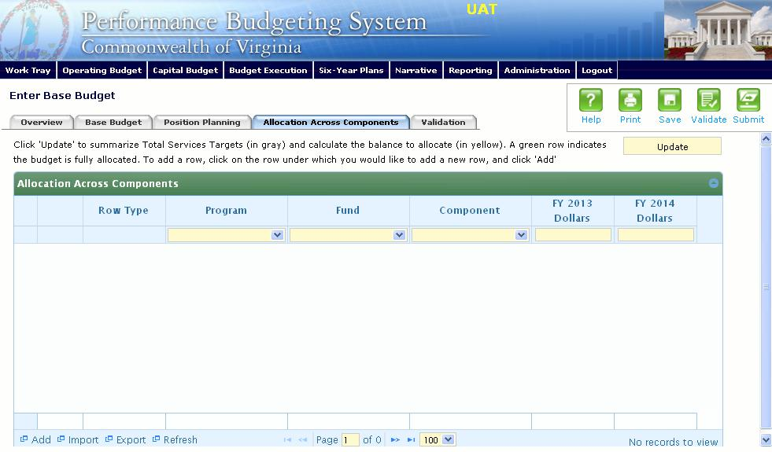
Components Instructions
- Click on the Allocation Across Components tab.
- Click on the Update button. This will populate the Allocation Across Components tab with your budget by program and fund/fund detail as allocated in the base budget total services grid. These lines will appear in the shaded grey rows. The balance to be allocated by component will be in the shaded yellow rows.
- Click on the balance row where you would like to add a new row, and click Add. In order to select the balance row properly, click the program field in the balance row. Keep adding rows until your budget is fully allocated by component.
- Click the Update button to check the balance remaining to be allocated. A green
shaded row indicates that your budget is fully allocated.
Components can also be imported into the grid. The best method for this is to export the grid after you have clicked Update. Add component records in the Excel file using the proper ID numbers, and re-import the data set. After you re-import you will need to click Update again.

Strategic Link

Strategic Link Overview
The purpose of the Strategic Link tab is to link GF/NGF appropriations by service area to the latest published strategic plan in the Performance Budgeting System. Agencies that do not participate in Performance Budgeting System Strategic Planning should uncheck the Strategic Planning allocation not required box as indicated on the Overview tab instructions.
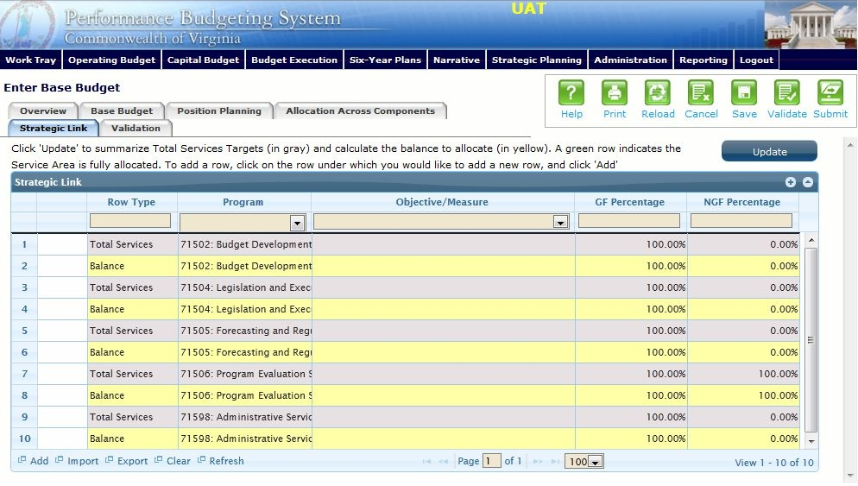
Strategic Link Instructions
- Click on the Strategic Link tab.
- Click on the Update button. This will populate the Strategic Link grid with the program-service areas included in the total services grid in the Base Budget tab. You should not complete the Strategic Link tab until you have completed arraying your budget on the Base Budget tab.
- Each service area in your base budget will be populated with two rows;
  - 1) a grey shaded Total Services row that is populated with either 0.00% or 100.00% under the GF and NGF columns depending on whether there are funds budgeted in that program-service area for GF or NGF.
  - 2) a yellow shaded Balance row that contains the balance remaining to allocate for the service area expressed in percentage terms.
- The goal of the Strategic Link tab is to allocate your budget to objectives and/or measures in your Strategic Plan. To do this, you will need to add rows to the Strategic Link grid and enter the program-service area, the agency or program-service area level performance measure or objective you would like to allocate the service area to, and the percentage of GF and/or NGF for the program-service area in question that applies to the measure or objective selected.
- To add new rows, click on the balance row where you would like to add the row, and click Add at the bottom of the grid. In order to select the balance row properly, click the program field in the balance row.
- You may choose to array your program-service area budget by either measures or objectives. The objectives and measures are listed in a tree-structure in the look-up box in the Objective/Measure column.
- As you add rows and array service areas to objectives or measures, you may click the Update button to recalculate the yellow shaded Balance rows. After 100 percent of a service area has been allocated, the Balance row shading will turn green and the amount remaining to allocate will be 0.00%.
- Continue adding rows until all of your service areas have been allocated fully to performance measures or objectives.
- Click the Update button one last time after you have completed the allocation.

